Templates

- Choose File, New.

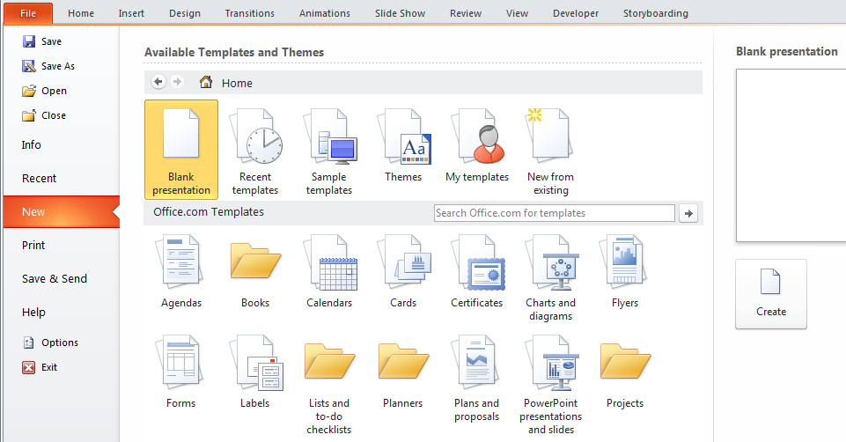
- …choose Create.
- Take a look at some of these which may take your liking and..

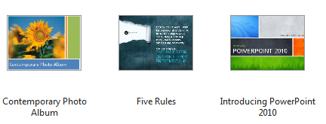

To Draw a Shape

From the Insert tab on the Ribbon choose Shapes and then choose a rectangle.

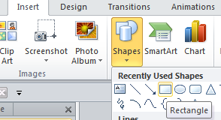
- Hint: To draw a perfect square, hold down the shift key as you are dragging.

- (Similarly to draw a perfect circle, hold down the shift key as you are dragging an oval shape.)

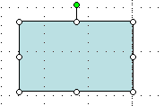
- Click and drag a rectangle.
You may wish to change the interior to white. Right click and choose Format Shape etc.

Rotating Text and Shapes

We have previously seen how to rotate using the green rotate handle.simply use the green rotation handle) Alternatively right-click on the rectangle and choose Format Shape.

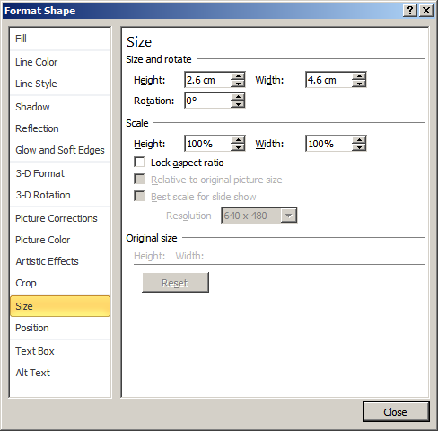
- Experiment with these.

- Note the effect of Lock aspect ratio when dragging the shape to change its size.

Nudge

- Highlight our rectangle and press the arrow keys – up down left right. Also we could choose the Format tab and then Arrange Group Rotate etc.
- To move or "nudge" the shape in very small increments, hold down CTRL while you press the arrow keys

Order

- Make two overlapping images as shown here.

The red rectangle is behind. We wish to bring it to the front.

- Right-click the rectangle which we wish to bring to the front and choose Bring To Front, Bring To Front.


- The rectangle is now at the front.

We could also choose the Format tab and then the Arrange Group.



AutoShapes

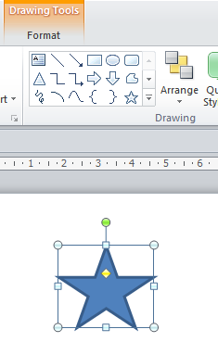

- Choose the Home tab and then Drawing Group. Experiment with these. Choose the star for example.

- .Click and drag a star.

Shadow

Can be applied to text or shapes (Select the shapes, eg a rectangle first of course)

- Right-click on the object and choose Format Shape… etc.

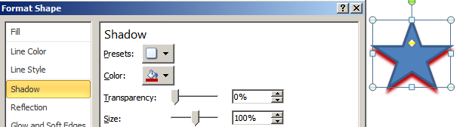

Experiment with these settings.

3-D Styles

Make sure that the object is selected and then choose the Format tab (otherwise it won’t appear) and chose Shape effects.… etc. (Or right-click etc)

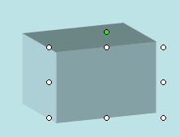

- You can even change the amount of tilt etc!

Group

First select the objects to be grouped. This can be done in two way.

- Select one object (ie click on it). Hold down the shift key and select the other.

- 2. Drag the cursor from top right to bottom left. A guiding rectangle temporarily appears.

In any case., the objects will appear selected as below.

- Right-click on them (careful not to deselect them) and choose Grouping, Group.

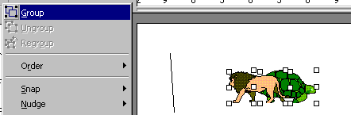
Make sure that the objects are selected and then choose the Arrange tab. Choose Group.

- The objects can be moved, copied resized etc as one.

- To ungroup them, right-click and choose Grouping, Ungroup.

Format Painter

This is much the same as for Word etc.

Formatting from one object can be immediately applied to another object.

If we have a box with a desired 3-D effect and we wish to apply the same 3-D effect to an ellipse that we have just drawn shown below.

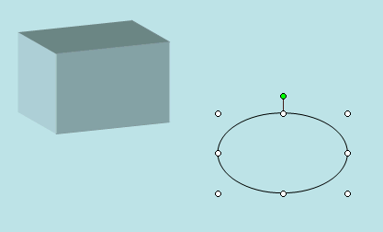
In PowerPoint 2007/2010 choose the Home tab and then Format Painter.

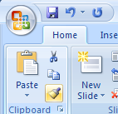

- Click on the rectangle to select it.

- Click the format painter brush.

- Click on the ellipse to select it.

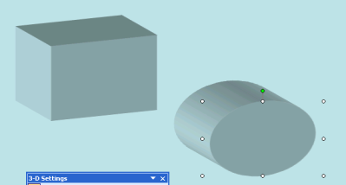
- The ellipse will receive the same 3-D effect.

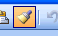
If we double-click on the format painter brush, it remains depressed and we can apply the formatting to more than one object.
To Draw a Curve

- Choose the Home tab and then the Drawing tab.

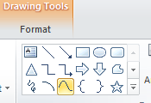

- Choose Curve.


- Click here to start.
- Then click here.

- Then double-click here. (If further "waves" are desired, single-click here and continue.)
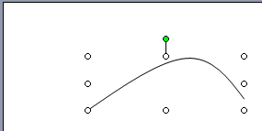

The curve is drawn:

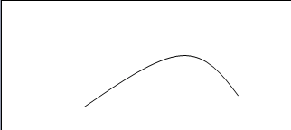

Scribble
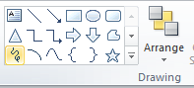
- Chose the Scribble.

To Draw a Freeform

- Choose the Home tab and then the Drawing
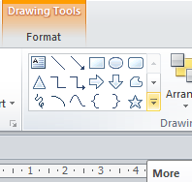

- Choose More..

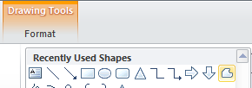
- Choose Freeform.

- Click here to start.
- Then click here.

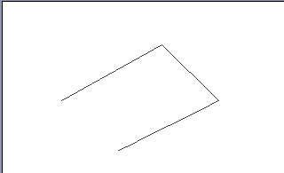

- Continue to click.

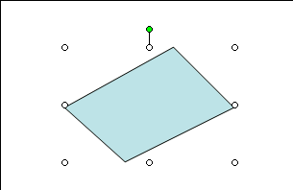
- Double-click to complete.

Connectors

- Choose the Home tab and then the Drawing tab.

- Draw a couple of objects.

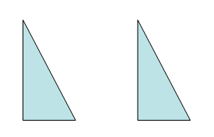

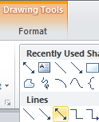

- Choose these lines.

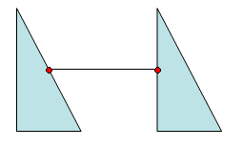
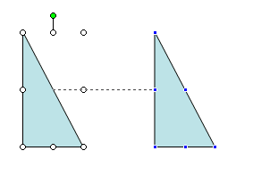
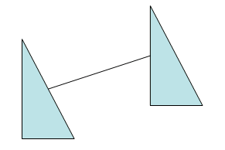
- Draw a connector between the objects. Blue handles appear so that the connector can be snapped to the objects.
- Drag an object. The connector remains in place!

Align and Distribute

- Draw some objects and select them using the Shift key as shown below.

(You may want to copy them using Ctrl-drag.)

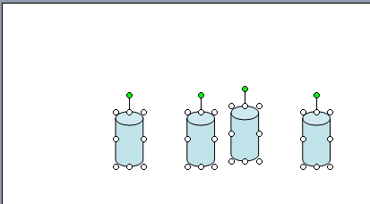
- On the Home tab choose Arrange.

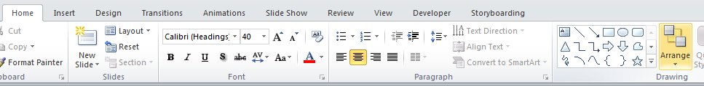

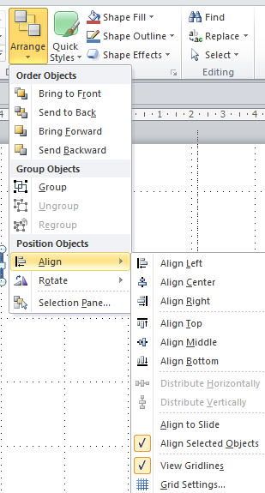

- Choose Align, Align Top.

- (If Align to Slide is checked, all four objects will be subsequently aligned at the very top of the slide.)

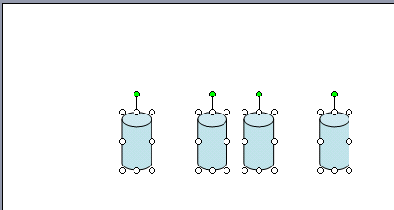

All four are aligned with the top-most.

- Choose Align or Distribute, Distribute Horizontally.

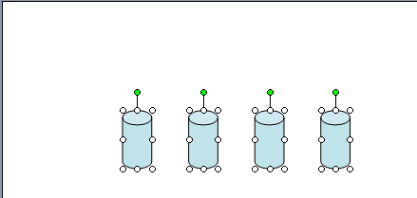

Same distance as before.

- If Relative to Slide is checked, all four objects will be distributed across the whole slide

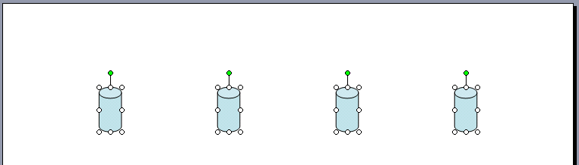

Grids and Guides

From the View tab choose Ruler or Gridlines or guides

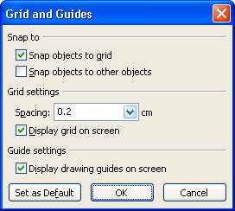
- (Checking Snap objects to grid will only allow objects to be placed on the slide so that the edges of the objects are on the grid.) (Holding down the Alt key will over-ride this.)
- Check these and click OK.

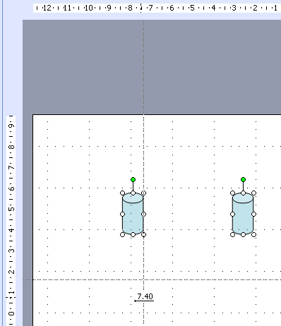
- As the drawing guide is dragged, the ruler measurement is displayed.
- (Turn on both rulers using View, Rulers from the menu.)

To Customize the Quick Access Bar

- Right-click in the Menu/Ribbon area.

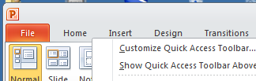
- Choose Customize Quick Access Toolbar,,.

Choose theView Tab and then the Slide Master View item and Add>>.

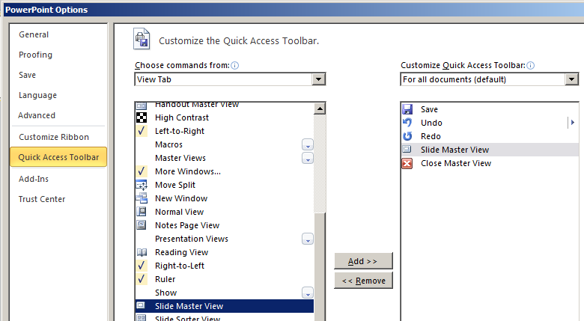

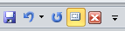
Also Choose
Close Master View as shown. You may have to choose All Commands here.

- Click OK to close.
Useful Shortcut Keys:
Ctrl-n for new presentation.
Ctrl-m for a new slide.
Ctr-z to undo.

Another Method of Getting Master View: (see later)
At the bottom right for PowerPoint 2007), you will see 4 mini buttons. They are: Normal View, Slide Sorter View, Reading view and Slide Show.
When you hover over these 4 mini buttons, hold down the Shift key. The mini buttons will now become Slide Master view, Handout Master view, and Set Up Show. (Unfortunately the tool tips no longer seems to tell us what they are.)

Slide Master 2010

It is a good idea to create a slide master before you even start to build any individual slides, rather than after. When you create the slide master first, all of the slides that you add to your presentation are based on that slide master and the associated layouts.

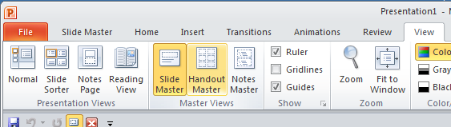

- First choose the View tab and then Slide Master.

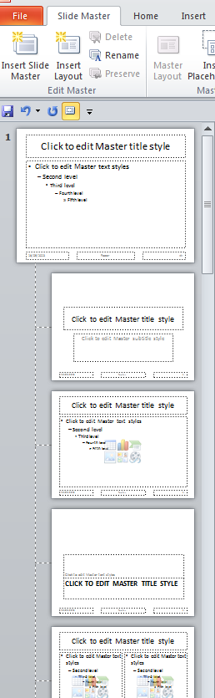
- (Or choose - in one operation- the Slide Master View on your Custom Toolbar.
A new presentation will have one Slide Master by default. You can add another if you wish.

These are only placeholders for text. They allow formatting of the text. This actual text "Click to …style" as shown here will not appear - anywhere.
It is just a “placeholder”.

We have hierarchy of masters.
(If you go to the Home tab and choose Layout, the slide templates available for a new slide correspond to these Master templates as shown here.)

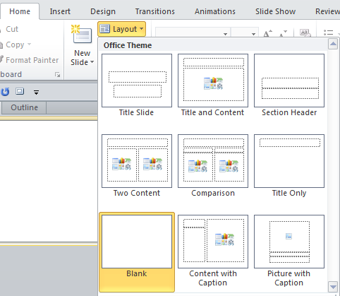

Note that we must CLOSE this Master Slide View if we wish to edit our slides.
You can’t edit a normal slide unless you do!

When we close the Slide Master it is automatically saved ie any changes will be automatically saved.
- Click here on the Slide Master tab. Note the Background choice available now.

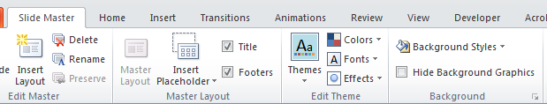

- Click here on the little arrow. The Format Background dialog box should appear as shown here on the left.

- Choose the top level master - the one at the very top - see below – we will see later that this is called the “Title Slide” and then…
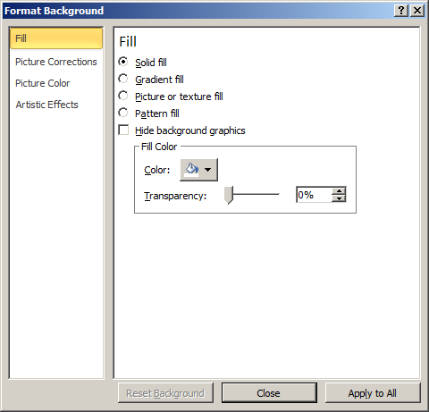

…choose a colour (eg Blue as below). Apply to All and then Close.

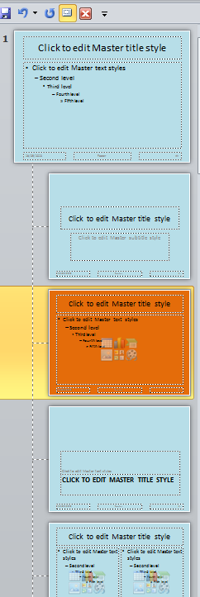
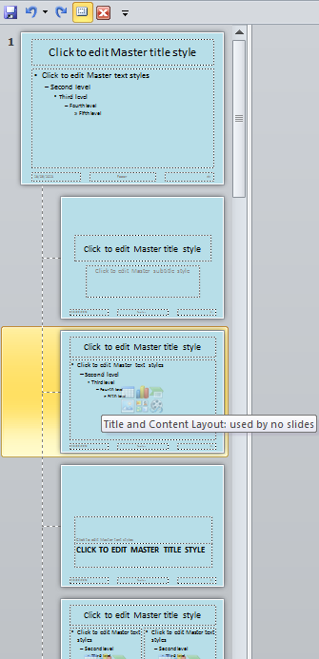

Note that they all now have a blue background.

- Choose a "lower order "master (say the 2nd lower one as shown here) and change the background colour shown here as orange as we did above. Don’t choose Apply to All.

Take note of the names of some of these masters,

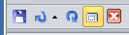
Use the shortcut button.
- Now we will make a new slide but first close the Slide Master!

Now if we were choose a new slide as follows:

- Choose the Home tab and then click the drop-down beside Layout

You can see that a new slide will have the background of the corresponding Master Slide chosen.

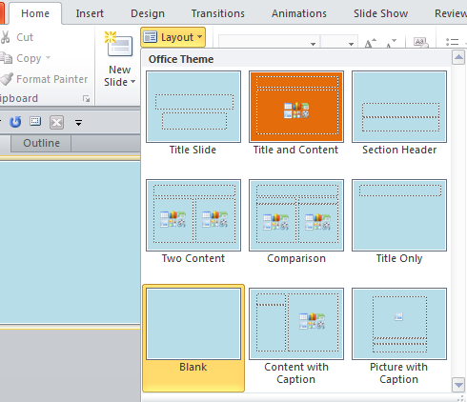

The second layout will produce an orange background layout.
All the rest are blue.

Title Slide The Title slide is the Top Slide Master"

eg Change the colour of the title on the "top" master to red as follows:

- View the Slide Master.


- Right click in the "Click to edit Master title style" text box at the very top.

- Choose Font from the drop-down and then colour the font say red.

Not from the Colors menu on the Themes tab as shown here.

ALL of the titles on all the Masters change.

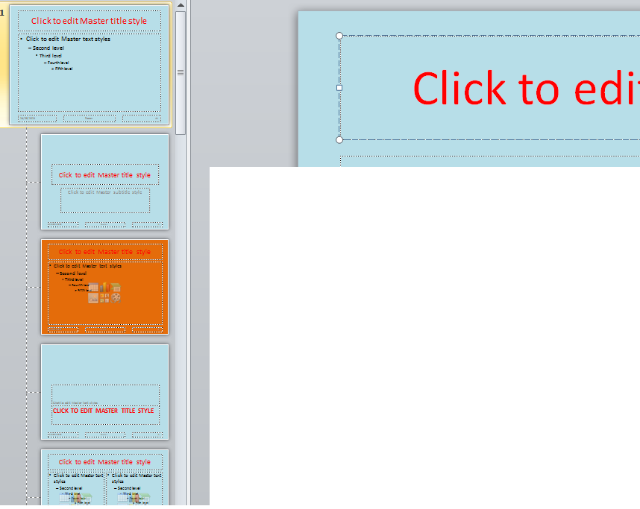

Now change say the first "lower" title to blue as shown below. (Double-click on it first and then edit it in the edit area.)

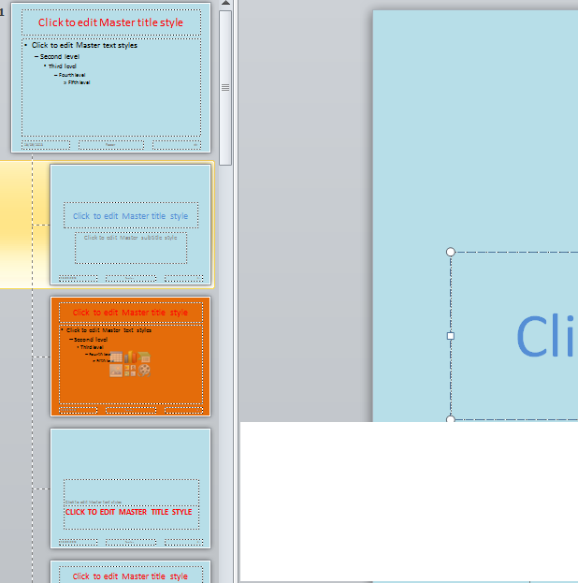

Any new slide made will have the Title text based upon the corresponding Master that you choose - Red or Blue. eg Choose the first layout. It will have a blue Title. (All the others will be red.)

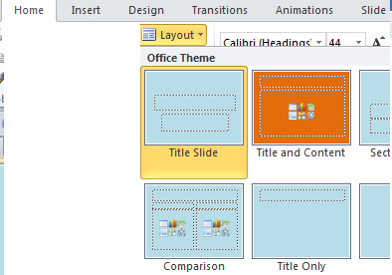

see also:
https://www.reading.ac.uk/web/FILES/its/PPSlideMasters2010.pdf

Exercise: Modify the Masters and place images etc. Note how if we place an image on a master it appears on every slide which is based on that master.

(You may wish to delete some “submasters”.)

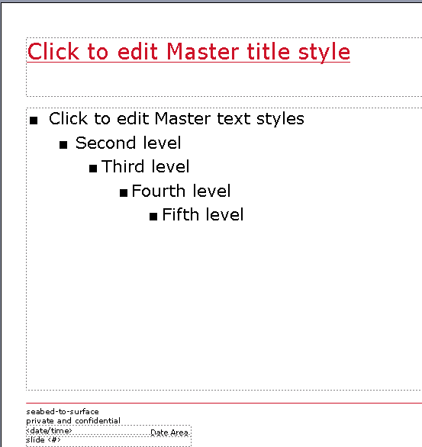
- Change the format of the Title.
- Draw some lines.
- Rearrange the text boxes. Include some new ones.
- Include a company logo if you have one. If not try an image.

Change the background colour if desired.

Placing images on the slide master saves a lot of memory space in your presentation. Your presentation could become bloated if you place it on every slide on which it is to appear.
To Create another Slide Master

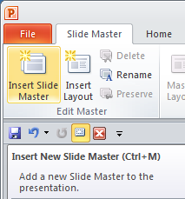
- Choose the Slide Master tab (you may need to choose the View tab first) and then Insert Slide Master.

We could for example have the first half of our presentation based upon one master and the 2nd half based upon another.

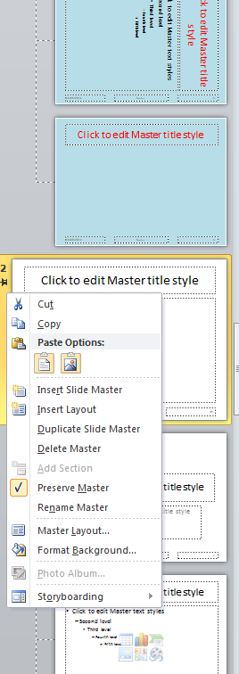

A new Master appears.

- Right-click on the new Title Master of the new master and rename to Eds.

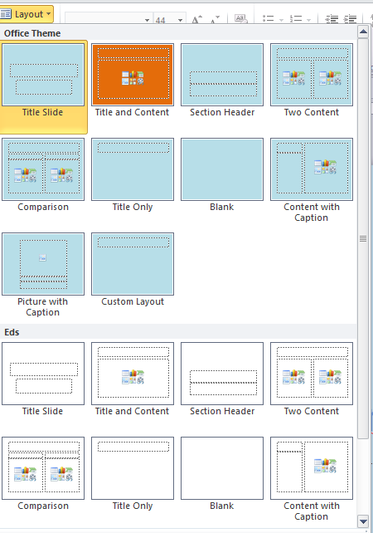

- Change to Slide Layout and notice the Eds master is available.

To make New Slides using Outline View PowerPoint Part3

Outline View can be used to produce titles and "body text" as follows.

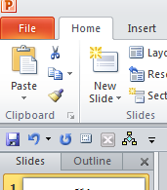

- Type your title here.

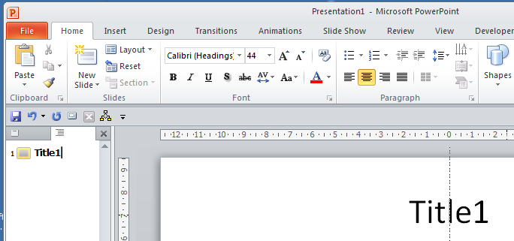

Click Outline.
- Place the cursor at the end our title and press Enter.
- Note that it appears as the title of our slide. The title has been placed in a special Title text-box.

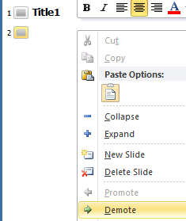
- Right-click here.

- From the drop-down menu choose Demote.

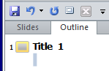
- The next line is demoted. Type Body Text 1 as shown below.

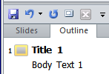
- Place the cursor at the end of the body text and press Enter.

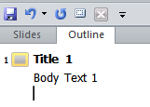
Your flashing cursor should now be here. Right-click and choose the left-pointing Promote arrow.

You should now have this:

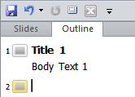

Repeat the process.
Type Title 2 etc.
A new slide is created!
etc..

The objective is to achieve this:

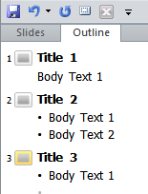

ie in Slides view you should have this.
